1)

a)



b)

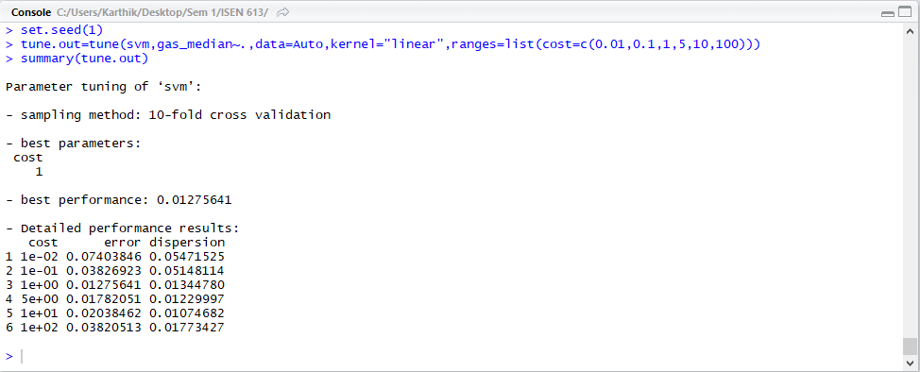

The error is the least for the case where cost=1 based on the 10 fold cross validation.

c)

POLYNOMIAL KERNEL:

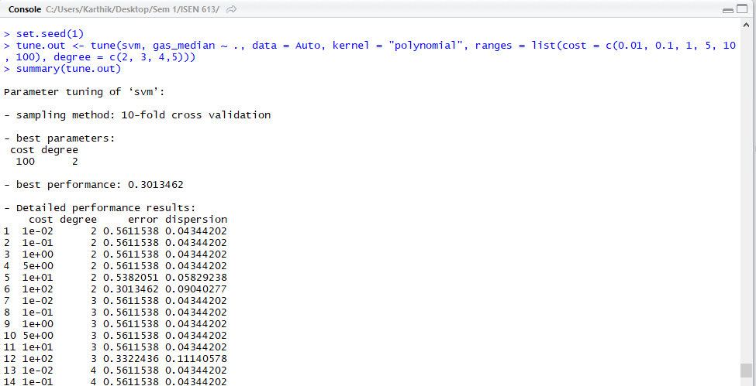

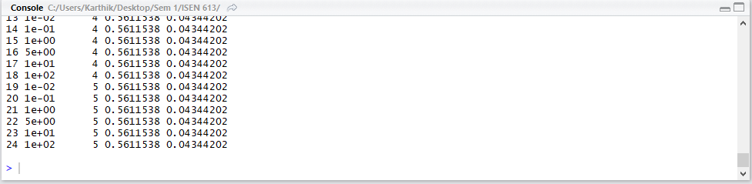

cost=100, degree=2 has the best result according to the lowest cross validation error for the polynomial kernel.

RADIAL KERNEL:

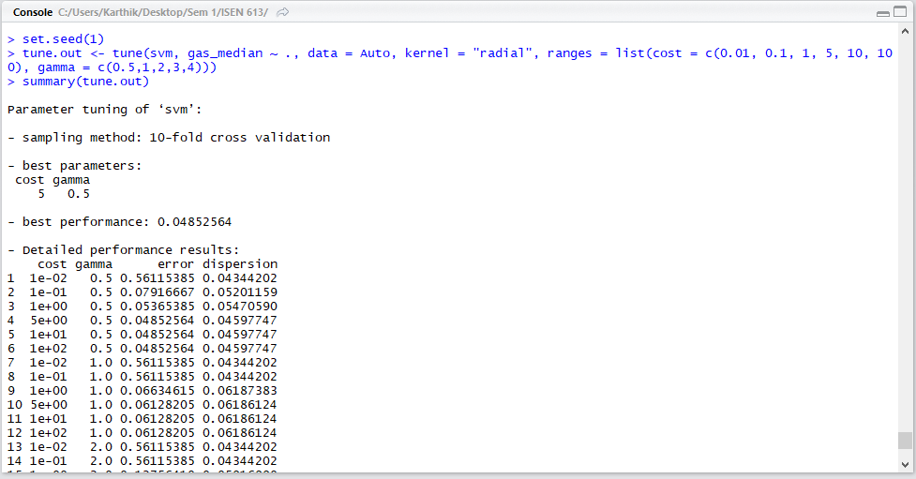

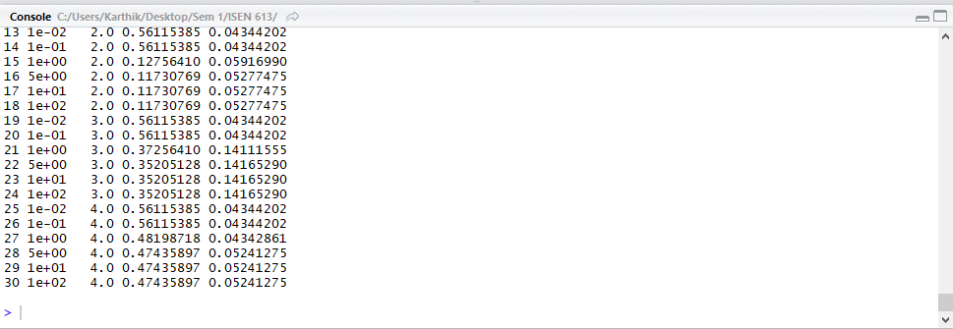

For the considered values of cost and gamma, gamma=0.5 and cost=5 gives the least cross validation error for the radial kernel.

2)

a)



b)

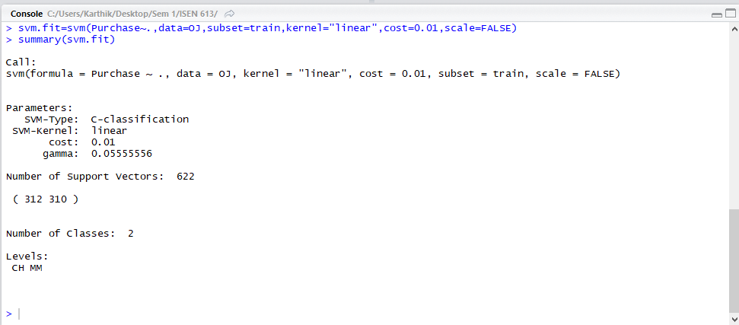

Number of support vectors in this case is high = 622, out of which 312 belong to CH and 310 belong to MM in the 800 training values of ‘purchase’.

c)

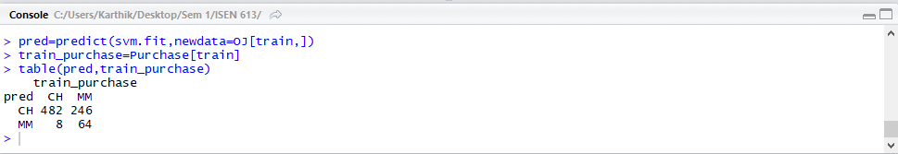

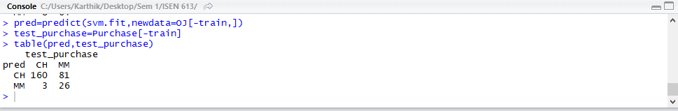

Training error=1-0.6825=0.3175

Test error=1-0.68=0.311

d)

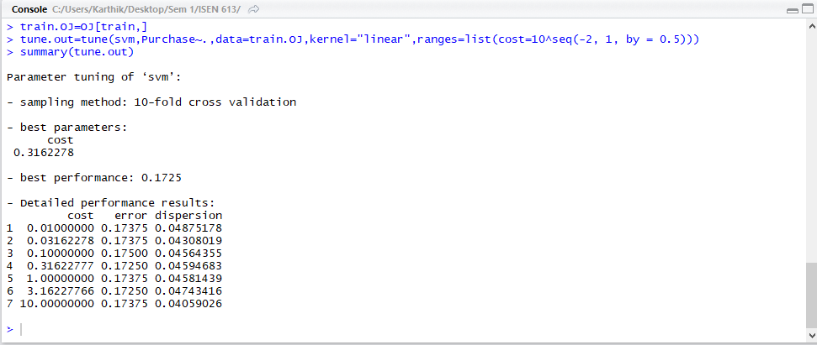

Optimal cost=0.3163,

e)

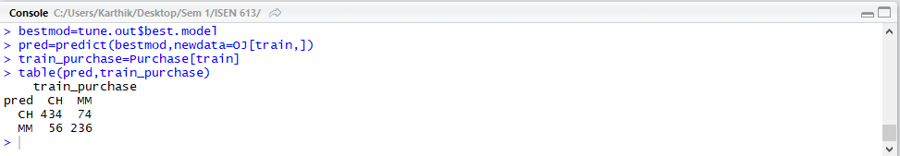

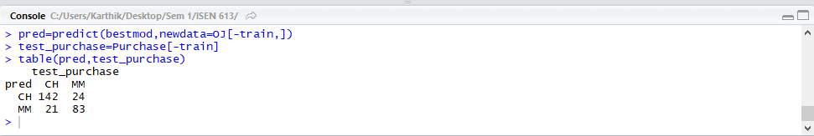

Training error0=1-0.8375=0.1625

Test error=1-0.833=0.167

f)

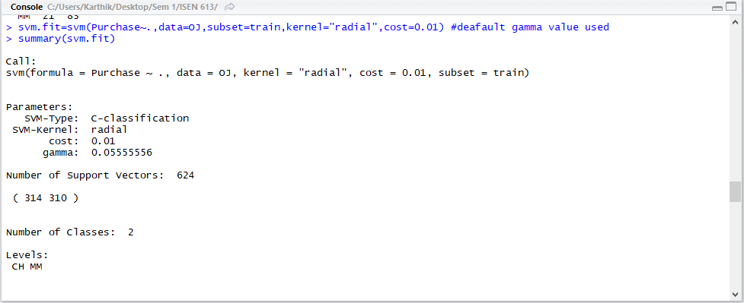

Number of support vectors in this case is high = 624, out of which 314 belong to CH and 310 belong to MM in the 800 training values of ‘purchase’.

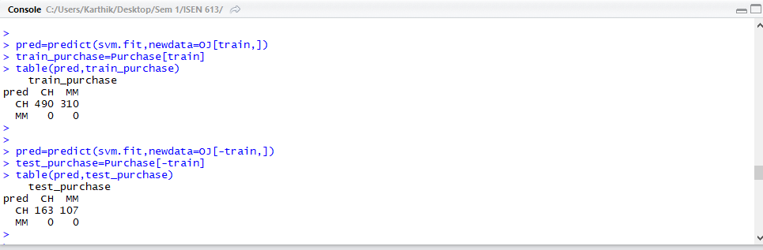

Training error=1-0.6125=0.3875

Test error=1-0.604=0.396

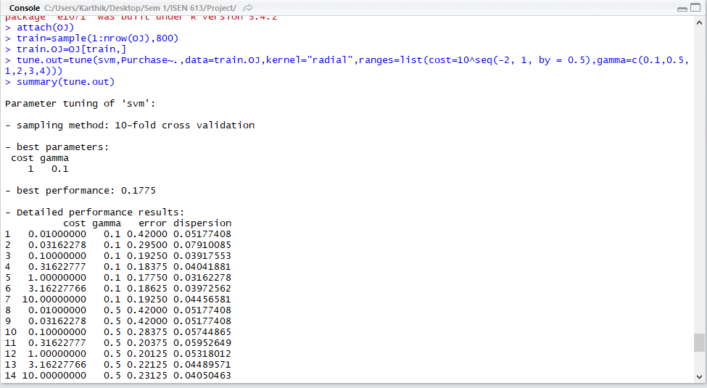

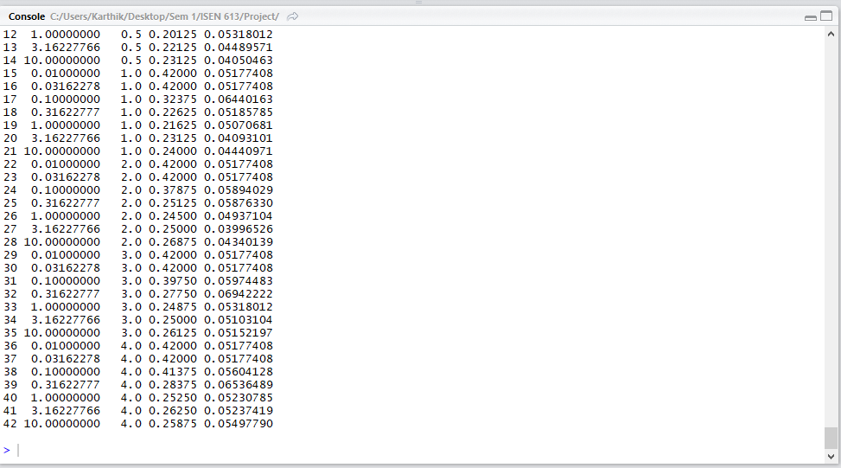

Optimal cost=1

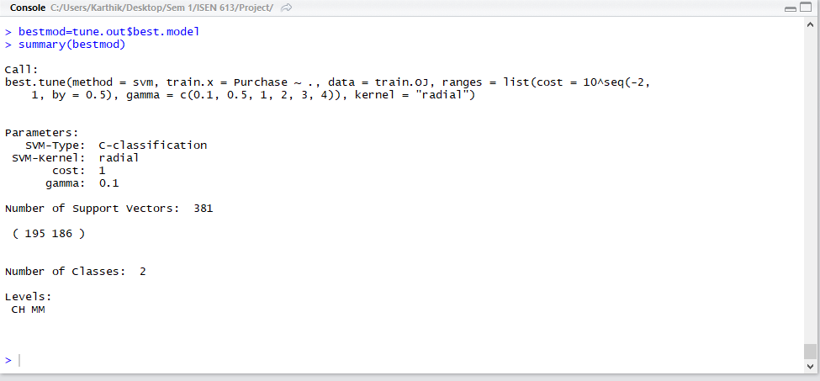

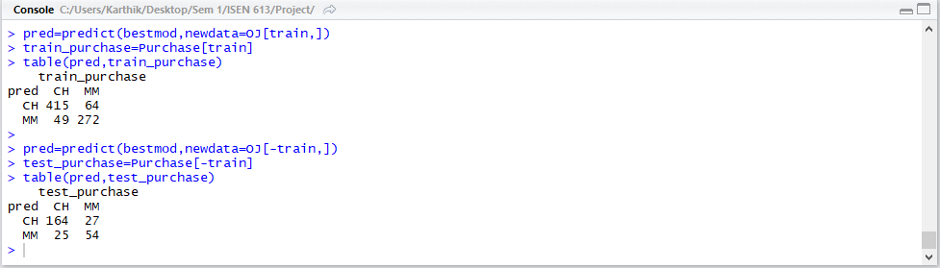

Training error=1-0.859=0.1413

Test error=1-0.807=0.193

g)

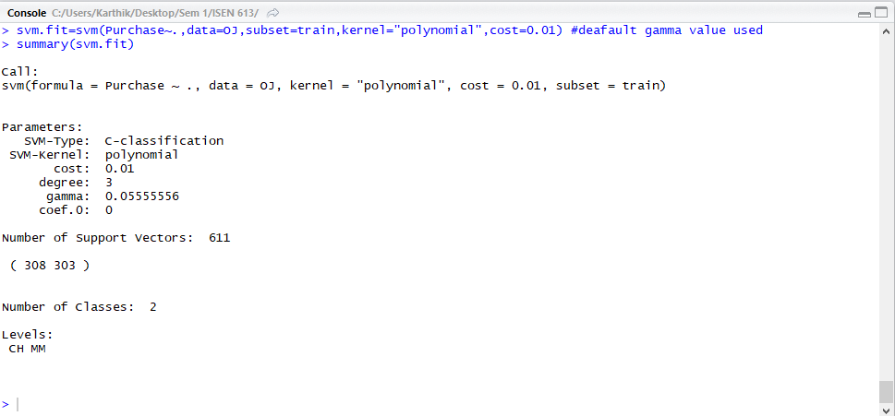

Number of support vectors in this case is high = 611, out of which 308 belong to CH and 303 belong to MM in the 800 training values of ‘purchase’.

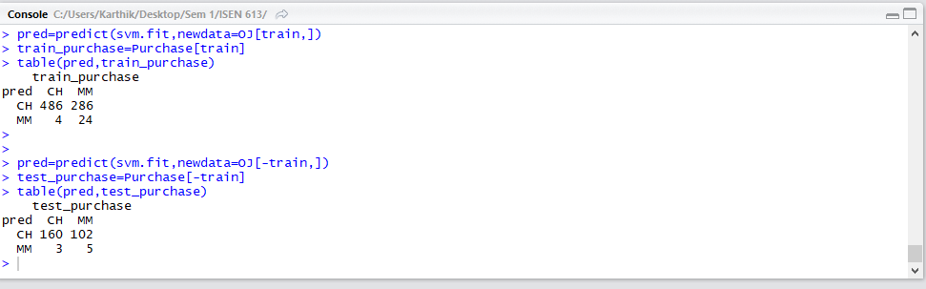

Training error=1-0.6375=0.3625

Test error=1-0.611=0.389

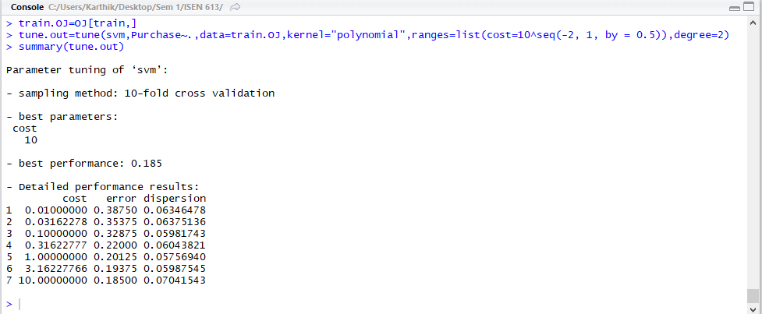

Optimal cost=10

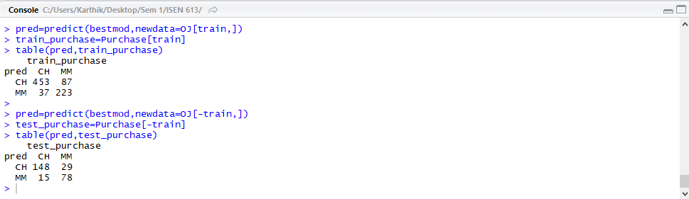Training Error rate= 1-[(457+223)/(453+87+37+223)=0.154

Test error=1-0.837=0.163

h)

|  |  |  |
| --- | --- | --- |
|  | **TRAINNIG ERROR** | **TEST ERROR** |
| **Linear Kernel** | 0.1625 | 0.167 |
| **Polynomial Kernel** | 0.154 | 0.163 |
| **Radial Kernel** | 0.1413 | 0.193 |

According to the test errors, Polynomial Kernel gives the best results and seems to be the most accurate in classifying the ‘Purchase’ followed closely by the Linear kernel and radial kernel.